J. Packy Laverty J. Packy Laverty, PH.D. Professor of Computer Information Systems, z Systems Enterprise Coordinator Robert Morris University, Pittsburgh, PA
laverty@rmu.edu

Introduction to APplication Programming
Spring 2017

Contents
1.0 A Programmer is a Teacher 3
2.0 First Generation Program Languages -1GL - Machine Language 4
2.1 The native language of any processor is binary code, or machine language 4
3.0 Second Generation Program Languages - 2GL - Assembly Language 5
3.1 Advantages of Assembly application development 6
3.2 Disadvantages of Assembly application development 6
3.3 Future of Assembly Language 6
3.4 Disassembly and Reverse Engineering 7
3.5 Sample Assembly Program 1 8
3.5 Sample Assembly Program 2 9
4.0 Third Generation Program Languages (3GL) - C, COBOL, FORTRAN 11
4.1 One-to-Many Instruction Mapping 11
4.2 Machine Independence 11
4.3 Level of Abstraction – Faster Development versus Performance and Flexibility 11
5.0 Procedural versus Object Oriented Program languages 12
5.1 Procedural program languages 12
5.2 Object-oriented programming languages 13
6.0 Overview of Popular Third-Generation Programming Languages 14
6.1 COBOL (Common Business Oriented Language) - 1960 14
6.1 COBOL CARD IMAGE RULES 14
6.2 Sample COBOL Program 15
6.2 FORTRAN (Formula Translation) - 1957 16
6.3 Sample FORTRAN Program 17
6.4 Java (1995) 18
6.4.1 Java Software Platform and Packages 18
6.4.2 Structure of a Java Application 19
6.4.3 Open-Source Java Platforms and Editions 20
6.4.4 Java Proprietary Editions, clients and servers 21
6.4.5 Interpreting the Java Platform/Edition Name 21
6.4.6 Sample Java Console Interactive Application to Calculate a Mortgage Payment 22
6.5 C/C++ (1973, 1979, 1999, and 2008) 23
6.6 C#, VB and ASP.NET - The .NET Framework (2001, 2015) 24
6.6.1 Sample C#.NET Form and Textbox to Calculate a Mortgage Payment 25
6.6.2 Visual Basic and VB.NET 26
6.6.3 Sample VB.NET Form and Textbox to Calculate a Mortgage Payment 26
6.6.4 ASP.NET and the .NET Framework 27
6.6.5 ASP.NET Razor 29
6.6 Objective-C/C++ -1983, 2007 30
6.7 Swift - Apple/Open Source 2015 30
6.8 PHP 31
6.9. Python 32
6.9.1 Introduction 32
6.9.2 Data Analytics: R versus Python 32
6.9.3 Python Sample Code 32
6.10 Scala 33
6.10.1 Introduction to Scala and Functional Programming 33
6.10.2 Scala was designed ot overcome Java's shortcomings. 33
6.10.3 Big Data Analytics: Hadoop and Spark 33
6.11 R Programming 34
6.12 Rexx 35
6.12.1 Introduction 35
6.12.1 Advantages of Rexx 35
6.12.3 Rexx Program Example 35
7.0 Frameworks - What is a Java or .NET API Framework? 36
7.1 Java Platform/Edition, Java Framework, and Java Package 37
7.2 Java Library, Java Package, Name Spaces, Java Framework, and Java API 37

1.0 A Programmer is a Teacher

A programming language is an artificial language designed to express computations that can be performed by a machine, particularly a computer. Or with another words, programming language is a vocabulary and set of grammatical rules for instructing a computer to perform specific tasks.

Everyone can probably name several computer programming languages. For example, popular procedural languages include C and COBOL. Newer Object-oriented program languages include C++, Visual Basic, C# and Java.

One role of a computer processor is to transform input data in useful information or outputs. But, a processor has no intelligence to perform these tasks. Someone has to TEACH, or instruct, the processor to do something.

A computer programming language is the language and communication process to teach the processor to perform a specific task, similar to a teacher who teaches his/her students to perform a specific task. However, teaching a processor what to do is more complicated than teaching one of my students. Consider why I prefer teaching students than teaching a computer processor:

- My students understand English. Processors only understand only binary.
- My students tolerate a missing comma, mispronounced word or hoariness in my voice. Processors expect an exact sequence of bits; there is no room for fudging.
- My students can learn through various media, the processor can only learn from an exact electronic signal. Voice or touch input data must be converted to these
- And most important difference, a processor is dumber than any person that either you or I have ever met.
- A computer simulates human intelligence through a series of computer programs and instructions called Artificial Intelligence (AI). If the AI program is incorrect, then the simulated intelligence results will be incorrect. At least my students known when I make a mistake!

In order to program, you must first be a good teacher. You need to know what to teach. In programming jargon this is called program specifications or program requirements. You need to anticipate the unknown. Consider the following program example.

In the mid-1960s ConEdison, an electric utility in NYC, introduced the first computerized electric bill. A customer had his electric service disconnected and received a bill requesting that he pay $0.00 dollars.

Of course, the customer ignored the bill.

Several months later the computerized electric bill demanded immediate payment of his overdue balance of $0.00 dollars.

After a final threatening "Disconnection Notice letter" demanding his immediate remittance of $0.00. The customer mailed a check for the amount $0.00 dollars.

As you can probably guess, his next month's bill read "Thank you for your payment of $0.00 Dollars".

And we blame the Computer, and not the Programmer.

2.0 First Generation Program Languages -1GL - Machine Language

The only programming language that a computer's processor can understand and execute is called binary code. Binary coded programs are specific sequences of 0s and 1s used to represent data and to computer instructions which are properly formatted that the computer understands.

These binary processor instruction programs are called Machine Language programs. The exact combination of 0s and 1s are specific to the instruction set used by the processor that will execute the binary program. Memorizing and writing binary instructions was very tedious, error-prone, and was not very portable to other processors.

Machine Languages are stored in a file or data set member so that they may be executed many times in the future. Windows stores machine language instructions in files described as .EXE, .COM, or DLL files. A z/OS mainframe stores machine language instructions in a data set member call a Load Module. The following is an example of the displayed content of Load Module. As humans we cannot understand this electronic content, but the processor can execute this binary content. The following is displayed example of a z/OS load module.

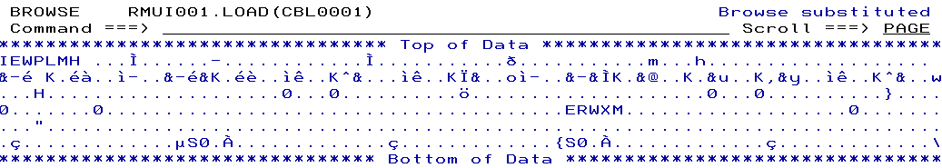

2.1 The native language of any processor is binary code, or machine language

Given the human limitations to code a machine language program it was learned very early that a better way was needed to write binary coded programs. The evolution of programming languages beyond machine language instructions are organized in Program Language Generations, e.g., 1GL, 2GL, 3GL, 4GL, and so forth Just as a history teacher teaches the history of human development and evolution, this course teaches the evolution of program languages and differences between program languages.

Some assume that "First Generation" languages means old-fashion. 1st-Generation Programs Languages are called machine language based on a binary language required by specific processor. There is only ONE machine program language for a given processor. Machine language is specific to the instruction set of any processor and binary codes used to represent data. It is the only programming language that the processor understands.

All other programming languages MUST be translated into Machine Language. While machine language is very fast and efficient, no one wants to code programs in machine language unless it is absolutely necessary. Hence, higher level programming languages generations were created and each programming language had its own translator: Compiler, Interpreter, or Assembler.

3.0 Second Generation Program Languages - 2GL - Assembly Language

2GLs are called assembly languages, or low-level languages. Assembly mnemonic instructions and parameters (abbreviations) were easier to understand than machine language. Assembly language applications were better organized. For example, each assembly language instruction was organized similar to a processor instruction but was easier to understand. Consider the following assembly code snippet.

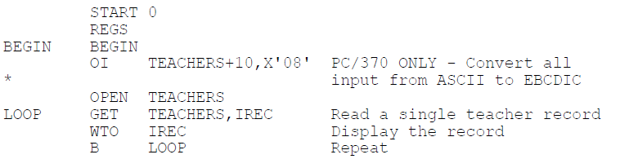

- Labels - Any memory location within a sequence of instructions could be identified by a label. For example, BEGIN and LOOP are procedural labels, like a paragraph is in COBOL, method in Java, or a procedure in C. TEACHERS and IREC are file and record label. Variable labels are not provided. Labels are for program control.
- Opcodes - Each binary instruction, e.g., 000101000100000, was represented by a mnemonic or operation code (opcode) - ADD. A little bit easier to remember ADD instead of the binary instruction. OI, OPEN, GET, WTO are examples of assembly mnemonic instructions
- Dataset, Record or Variables- Each memory location that was used to store data could be identified and its contents changed. Variable names were not used. Most assembly operation codes are followed by a dataset, record or identifier and data type. Some instructions include a operational parameter to provide information to the operation. Similar to high-level program languages, an assembler to automatically assign memory locations and process different data types.

An assembler is special translator program that translates assembly language instructions into machine languages. Assembly languages map one operation code (opcode) to one assembly instruction. This program language is called one-to-one mapping and has no level of abstraction (to be discussed later). Assembly languages were very popular in the 1950s-1970s. Assembly Languages were used to create operating systems, device drivers, and some applications.

One may categorize the more popular Assembly Languages as either IBM System z or Intel/AMD/embedded device. IBM developed the first assembly, low-level programming language for the System 360 operating system in 1964. This first version was called Basic Assembly Language (BAL). Since ALL future IBM processors are backward compatible (unlike Intel and AMD), BAL is still in use today. The current version of IBM System z Assembly Language is called High Level Assembler (HLASM) and its executable code may be executed on both z/OS and zLinux platforms.

The use of Intel/AMD assembly language programming development has declined and has been replaced with C and C++ applications for low-level requirements. Many embedded devices still continue to assembly language to code applications for your car's internal processors, robotic machinery, advanced medical devices, and other performance critical devices.

3.1 Advantages of Assembly application development

1) Performance and Efficiency. Since each assembly language instruction may be mapped to each computer instruction, a skilled assembly language programmer can code a program that executes at the full speed of the processor. No higher generation program language or programmer can execute at full speed. The drop-off of execution efficiency starts at a level estimated 10% decrease and frequently performance decreases is as much as 30%. Higher level compilers and other translators have limited ability limited to optimize executable code performance, and hence are ALWAYS slower than assembly applications.
2) Any task or memory area that the processor can execute, an Assembly programmer can code and control. No higher-level generation program language can perform every task that the processor can execute. From a flexibility point of view, the C programming language, if properly customized for specific implementation of a processor's architecture, is the closest program language to assembly.
3) Higher- level program languages know nearly nothing about the hardware and often have no ways of accessing it.

3.2 Disadvantages of Assembly application development

1) Long and tedious to write, debug and maintain.
2) Each version of assembly language was "married" to the instruction set of specific implementation of a processor's architecture.
3) The code is normally not portable to other processor architectures
4) Increased security concerns.
5) Fewer programmers understand and are able to code and maintain assembly programs.

3.3 Future of Assembly Language

IBM's HLASM and BAL assembly languages are widely used by over 90% of the Fortune 500 companies for mission critical applications, e.g., credit card processing, high scale transaction processing, or to supplement more popular higher-level program languages. An application system or library may include a combination of C/C++, COBOL, Java and Assembly language executable programs.

Fewer and fewer programmers have or are willing to learn assembly language. If the application requirements do not involve video games or mobile devices, assembly language programming is boring no matter how attractive the salary level may be. As a result, some major IBM customers are attempting to replace assembly coded subsystems code with C/C++ source code. There are more C/C++ programmers available. This success of this emerging trend is uncertain since these subsystems do not involve video games or mobile devices. New Computer Science and Computer Information Systems graduates love to program the "cool" apps.

Since processor and hardware performance and control are important requirements for embedded devices and processors, e.g., your car, robotic machinery, advanced medical devices, etc., assembly programming will never die.

3.4 Disassembly and Reverse Engineering

A disassembler is a computer program that coverts machine language application into assembly language instructions—the inverse operation to that of an assembler. A disassembler differs from a de-compiler, which targets a high-level language rather than an assembly language.

Since the machine language code (load module) is necessary for program execution, any person who has access to the executable program data file or data set may conduct a reverse engineering attack to 1) study the detailed function and logic of the program to reveal proprietary information, 2) see the content of password and security data, 3) or modify of the content of the executable program to perform a malicious task.

Reverse Engineering attacks are a threat to both assembly language and other higher-level program languages.

3.5 Sample Assembly Program 1

Assembly Language Program 1
Input a sequential file and output the contents of each record for a simple TEACHER file.

Input Data | Assembly Program | Output
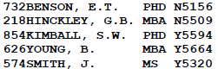 | 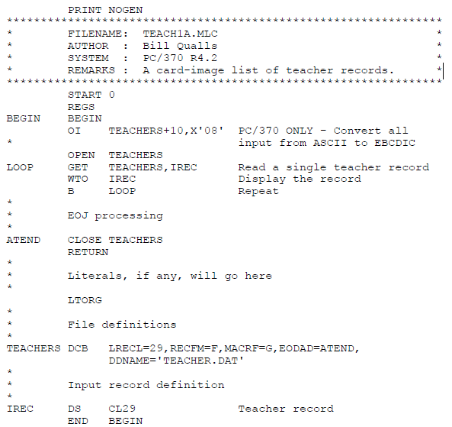 | 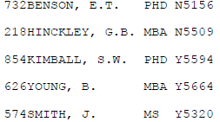

3.5 Sample Assembly Program 2

Assembly Language Program 2
Input a sequential file and output the contents of each record and field of the TEACHER file.

Layout of the teach file
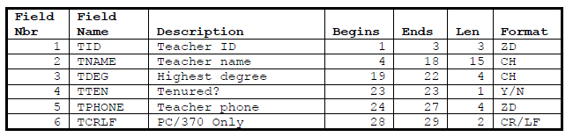

Data stored in the Teacher file

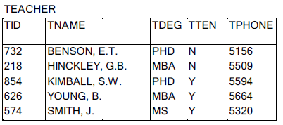

Output of the Assembly Language Program

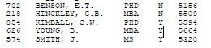

Assembly Program 2 Code

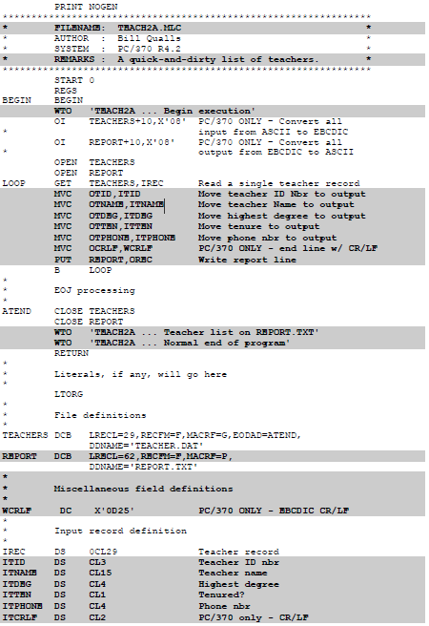
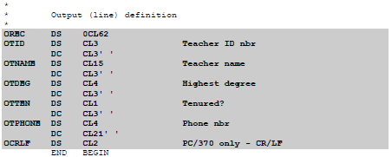

4.0 Third Generation Program Languages (3GL) - C, COBOL, FORTRAN

3GLs were designed to overcome the limitations of one-to-one instruction mapping and machine dependence. Third Generation Programming Languages may be classified as Procedural or Object-Oriented.

4.1 One-to-Many Instruction Mapping

Consider the simple task of displaying this letter "A". Humans believe that this a very trivial task, but in fact there may up to 20 separate assembly instructions that are required to be coded perform this tasks at the machine level. Wouldn't be easier if we would have a command like PRINT "A"?

3GLs introduced the concept of instruction explosion. A single 3GL command or statement, e.g., PRINT, could replace 20 opcodes. Fourth Generation languages have increased the level of instruction explosion and level of abstraction.

4.2 Machine Independence

Windows, UNIX, and Linux are coded in the 3GL language called C. C was designed to minimize the number of one-to-many instruction mapping while proving functionality to assembly language However, Cs greatest benefit was than it was machine independent. Unlike assembly language, the program language syntax of C is similar across most hardware platforms and may be compiled for a computer platform.

The Linux operating system which is written in the C program language. Can Linux be used with Android, Intel, AMD and IBM System z processors? The answer is YES. Simply compile the Linux source code with the appropriate C compiler for the processor type.

4.3 Level of Abstraction – Faster Development versus Performance and Flexibility

No discussion on program languages is complete without consideration of the concept called "Level of Abstraction." The objectives of modern programming languages with High Levels of Abstraction are:

- A syntax that is easier to understand,
- Coded faster with fewer errors,
- Does not require the programmer to know the details of code,
- Easier to organize, debug and test (modular),
- Easier to reuse program code in other applications and.
- Can be executed on any hardware platform

Each generation of program language has a higher level of abstraction than the previous generation. This is great! Get paid for a 40 hour work week and only work ten hours! Or if you are a manager, you can get more work out of the programmer for the same salary.

Reducing the length of a program code or the number of instructions to code is only one level of reusability of program code or increasing the level of abstraction. Other methods to promote usability of program code involve the use of subprograms, copy books, functions and external classes developed by other programmers.

For example, consider the PMT function in EXCEL. It is a built in program, or function, that a user can invoke =PMT(interest_rate, no_of_payments, principal) to calculate a mortgage payment. Java, Visual Basic, and C# provides pre-written APIs to make it easier for a programmer to code and develop GUI and web page interfaces. Java, Visual Basic, and C#

Are Java, Visual Basic, and C# better programming languages than COBOL, C, and Assembly languages? The answer depends on what you mean as "Better"? COBOL, C, and Assembly languages, which have lower levels of abstraction, simply execute faster. Should you purchase a faster server or processor? CIOs don't buy IBM System z mainframes and use COBOL simply because it is faster, it may be the only platform that may perform a business requirement for volume, through[put ,a and response time at a reasonable cost.

No matter what your professor told you in class, Fortune 500 companies not going to dump billions and billions of investment dollars in legacy COBOL program code and experience of their current IT professional staff. A modern CIO has to balance the advantages of a high level of abstraction for new application development with the business requirements and investment of existing legacy systems and programming languages.

For example, modern versions of COBOL will support web pages, web services (SOAP and RESTful), and mobile apps interfaces. Your Android mobile device App is a front-end, user-interface program that can remotely access your checking account. The backend system applications may be coded in COBOL. Should we replace legacy COBOL backend processing for checking account processing used for over 30 years to access legacy data bases with Java applications? The answer is NO! Your Android device sends web service message to the legacy COBOL program and nothing in the backend needs to be changed. Then again, should we code a NEW COBOL program to control a car's anti-lock braking system? The answer is obviously NO. COBOL was not designed for that task.

5.0 Procedural versus Object Oriented Program languages

Video - The difference between procedural and object-oriented programming - https://www.youtube.com/watch?v=OEfSFrk_KEI

5.1 Procedural program languages

Procedural program languages use a list of instructions to tell the computer what to do step-by-step. Procedural programming relies on - you guessed it - procedures, also known as routines or subroutines. Each procedure contains a series of computational steps to be carried out. Procedural programming is also referred to as imperative programming. Procedural programming languages are also known as top-down languages. The primary focus is on what is to be done, then what data is to be manipulated! Data and procedures are considered to be independent. Procedural languages are more focused on steps to be perform, rather than to reuse the code.

Procedural programming is intuitive in the sense that it is very similar to how you. as a human, would expect a program to work. If you want a computer to do something, you should provide step-by-step instructions on how to do it. It is, therefore, no surprise that the majority of early programming languages are procedural. Examples of procedural languages include FORTRAN, COBOL and C, which have been around since the 1960s and 70s.

5.2 Object-oriented programming languages

Object-oriented programming languages, or OOP, are an approach to problem-solving where all computations are carried out using objects. An Object contains both data and procedures rather than separating data from procedures. An object is a component of a program that knows how to perform certain actions and how to interact with data The primary focus is on what data is to be manipulated, then what is be done (methods) on the data! Procedures and data are dependent on each other. More focused on how to reuse code and data, that the steps to be performed.

Objects are the basic units of object-oriented programming. A simple example of an object would be a person. Logically, you would expect a person to have a name. This would be considered a property of the person. You would also expect a person to be able to do something, such as walking. This would be considered a method of the person.

A method in object-oriented programming is like a procedure in procedural programming. The key difference here is that the method is part of an object. In object-oriented programming, you organize your code by creating objects, and then you can give those objects properties and you can make them do certain things.

A key aspect of object-oriented programming is the use of classes. A class is a blueprint of an object. You can think of a class as a plan for a program requirement, and the object represents the execution of the program requirement. Classes are source code and Objects are executable code. So let's say you are provided program requirements to add, lookup, modify or delete the attributes of a student, e.g., name address, major, QPA, etc. One would code the class variables that describe the student record or attributes of the student, followed by the methods to perform add, lookup, modify or delete processing requirements. Examples of object-oriented languages include C#, Java, Perl and Python.

6.0 Overview of Popular Third-Generation Programming Languages

6.1 COBOL (Common Business Oriented Language) - 1960

COBOL was originally designed to process large amounts of input and output data using tape and disk files, which was common in business applications. Using COBOL APIs, COBOL is the most popular program language for accessing Enterprise DB2, IMS and Oracle Databases.

- COBOL lacked most of the mathematical functions and math operators as implemented in COBOL.
- Introduced by IBM in 1959 by Grace Hopper and IBM. Based on the 80-column punch card.
- COBOL has an English-like syntax designed to be self-documenting and highly readable.
- An Object-oriented Version of COBOL was introduced in 2002, and was improved in 2014 to better handle XML, web services and greater variety of data types.
- COBOL is supported by a variety of proprietary and open-source compliers which may be executed on most computer hardware are operating systems though most modern current COBOL application development versions will use a proprietary compiler.
- A COBOL plugin is available for the Eclipse IDE workbench. IBM includes their version of COBOL in the Rational Application Development for System z (RDz) IDE which can developed COBOL code locally or remotely on a z/OS system

6.1 COBOL CARD IMAGE RULES

In the early days of COBOL, the computer programmer would use a key punch machine to punch computer cards to write their program. Editors, like ISPF or RDz, were not available. Though we rarely use punch cards anymore, the tradition of the 80-column punch card lives on through COBOL Card Image Rules." These rules require that COBOL commands and syntax must be written in certain columns.

6.2 Sample COBOL Program
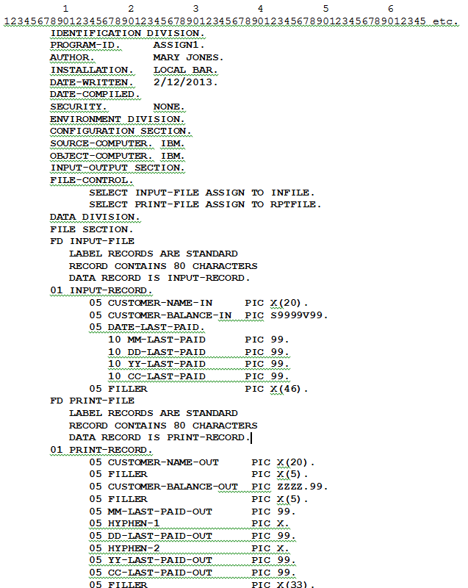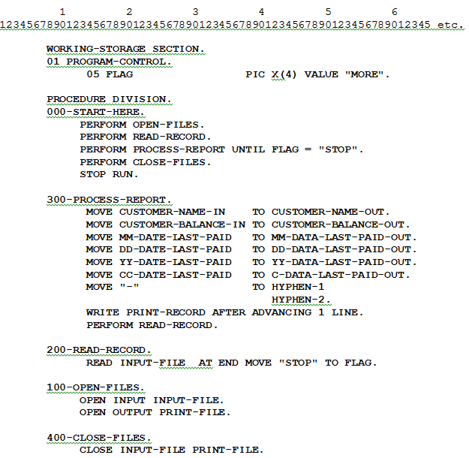

6.2 FORTRAN (Formula Translation) - 1957

FORTRAN was designed to provide numeric processing functions used in scientific and engineering applications.

- Introduced by John Backus and a group of IBM programmers in 1957 and is considered the first third- generation programming language.
- FORTRAN Versions 90 or 95 are currently the most popular
- An Object-oriented Version of Fortran was introduced in 2002, and a parallel computing version was introduced in 2008.
- Similar to COBOL FORTRAN uses the 80-column punch card format. Eclipse provides an open-source FORTRAN Plugin (Photran), but there are many proprietary versions of FORTRAN.
- In number-crunching FORTRAN still has an edge in speed over C and C++. Tests has shown that an optimized FORTRAN program in some cases runs up to 30 percent faster than the equivalent C or C++ program.

6.3 Sample FORTRAN Program

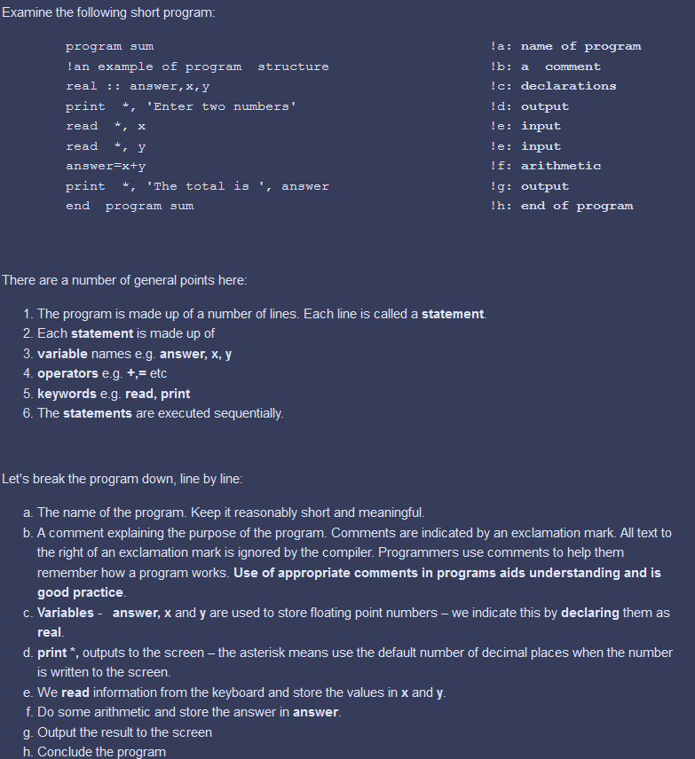

6.4 Java (1995)

- Java is a general-purpose, object-oriented computer programming intended to let application developers "write once, run anywhere" (WORA).
- Java was originally developed by James Gosling at Sun Microsystems in 1995. In May 2007, Java was became an open-source programming language and is supported by Oracle.

6.4.1 Java Software Platform and Packages

A Java Software Platform includes three major categories of software packages or components:

- Java Core APIs [List of API packages in Core Java. http://www.moreprocess.com/programming/java/list-of-api-packages-in-core-java]
- Java Optional/Extended APIs : Open source or Proprietary,
- Java Runtime Environment (JRE) which includes Java Virtual Machine (JVM) and Runtime Compiler.

If you are a Java Programmer you will need a combination of all three types of packages. If you are a browser user which will execute Java applications you may only need a Java JRE.

Types of Java Packages | Description | Comments
Java Core APIs | The Java language defines the syntax and semantics of the Java programming language. It defines basic vocabulary such as primitive types, if/else blocks, the syntax of class declaration, exception syntax, variable scoping rules, and everything else necessary for the language to function. | Are stored in packages which are folders or namespaces and java.*.  Java 7 introduced additional core APIs and are stored in the javax.* package.  These are the minimum APIs that are required to code a Java application.
Java Optional/Extended APIs | Are Java APIs that may be added to the Java Core APIs to specialize the development of a specific Java application | No programmer uses only the Java Core APIs. The Java Core APIs are packaged in a Java Platform or Edition.
Java Runtime Environment (JRE) which includes Java Virtual Machine (JVM) and Runtime Compiler | The Java Runtime Environment executes Java bytecode inside a Java (Application) Virtual Machine.  Java bytecode is created by compiling Java class code. | Most browser users may access a webpage or local app to execute Java Bytecode. These users will be required to installed the JRE

6.4.2 Structure of a Java Application

- A Java program is called a class.
- A Java package is a technique for organizing Java classes into folders or names Java packages can be stored in compressed files called JAR files.
- JAR files allow packages or classes to be organized by application or category, distributed and deployed (installed) for execution. One or more Jar files maybe further combined or compressed into a ZIP file to enable easier installation on Windows-based platforms.
- JAR files contain META data that documents the contents of Java Packages and application security descriptors.
- Java application security may be enforced at the class, JAR, or server level.

Java Core APIs | Java Development Kit (JDK) or Software Development Kit (SDK) | Java Software Platform or  Java Edition, e.g., J2EE, J2SE, J2ME, Java Android, etc.
Java Optional or Extended APIs | Java Development Kit (JDK) or Software Development Kit (SDK)
Java Runtime Environment | JRE

6.4.3 Open-Source Java Platforms and Editions

Popular Open-Source Java Platforms/Editions are distributed from Oracle for various operating systems. The following platforms will contain an SDK and JRE which have been system tested to ensure that all packages are compatible.

Open-Source Java Platforms/Editions | Description | Comments
Java 2 SE  (Standard Edition)  Version 8u74 | J2SE provides platform for development and deployment of portable code for desktops
Java 2 EE (Enterprise Edition)  Version 7u2 | J2EE is used to develop dynamic web applications that one normally sees in Blackboard or eCommerce applications.  J2EE adds the following Server Application APIs to Java SE:  Java Servlet, Java Server Faces, Enterprise Java Beans, RESTful Web Services, JSON Processing, Java EE Management, Java Message Service (JMS), Java EE Security | Java Enterprise Applications requires a J2EE application server to test J2EE web applications.  Oracle provides a light-weight open-source application server named Glass Fish. A more powerful open-source J2EE called Apache Tomcat is provided by the Apache Foundation  IBM WebSphere, Red Hat's JBOSS Middleware Suite, Oracle BEA services, and SAP NetWeaver provides proprietary applications servers and APIs than extends (improves) J2EE.
Java 2 ME (Micro Edition)  Version 8u2 | J2ME adds a flexible collection of APIs to Java SE to develop applications running on embedded and mobile devices in the Internet of Things: micro-controllers, sensors, gateways, mobile phones, personal digital assistants (PDAs), TV set-top boxes, printers and more.  Java 2 ME includes flexible user interfaces, robust security (smart cards), built-in network protocols, and support for networked and offline applications that can be downloaded dynamically. | Java 2 SE Embedded and Java Card may supplement or extend this edition.

6.4.4 Java Proprietary Editions, clients and servers

- IBM WebSphere, RedHat's JBOSS Middleware Suite, Oracle BEA services, and SAP NetWeaver provides proprietary J2EE-like applications servers and APIs than extends (improves) the open source J2EE standards.
- Many device manufacturers will provide APIs that will extend J2ME and will add functionally for their devices.

6.4.5 Interpreting the Java Platform/Edition Name

The following is a description of the details that will assist you to understand the following edition information.

Java 2 SE (Standard Edition) Version 8u74

Java 2 - The number 2 represents level of Java Core APIs, The Java Core APIs have not changes since Java version 3 and the number 2 is often omitted.
SE (Standard Edition) (Platform) describes the collection of extended or additional APIs that are used to local desktop application.

Most of the SE Java libraries are also used and extended in other Java editions or proprietary APIs. For example the EE (Enterprise Edition) and IBM Web Sphere also use many of the SE APIs.
Consider the SE Edition as the based edition, which contains fewer APIs requires less storage. There is no reason to install Java EE or Java ME unless you intend to develop web of embedded device applications. However, you may install a higher level edition later.

Version 8 is the level of a major change for the Java Platform/Edition's SDK Platform.

- Normally the Java SE Platform version will be changed first, and later the other extended editions will be changed.
- If you are running older Java applications to correctly functions under an older version, it may NOT be recommended to update to a new version unless you verify the new version is appropriate. Since previously developed Java applications were coded for a specific version, an updated version may not function correctly.
- It is possible to install multiple versions of the SDK or JRE on a computer to benefit from the new features introduced by the major changes of the version, as well as, provide backward compatibility for older versions.
- The frequency of Java versions in recent years may introduce a new Java version between three to five years since the previous version.

u74 is update level for a given Java Version.

- Normally, a Java version update will correct a critical bug in Java Version.
- It is ALWAYS recommended to keep your Java version (SDK and JRE) updated.
- Critical version updates are normally scheduled every three to six months. Older Java versions are also updated.

6.4.6 Sample Java Console Interactive Application to Calculate a Mortgage Payment

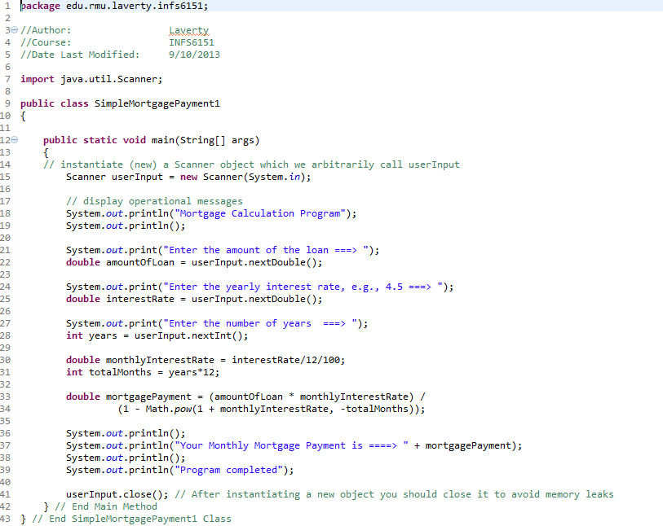

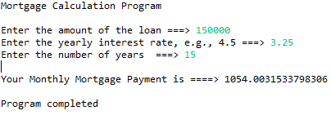

6.5 C/C++ (1973, 1979, 1999, and 2008)

- C was designed as a general-purpose, procedural programming language that permitted access to the computer hardware and all memory areas
- C was introduced in 1972 by Dennis Richie at AT&T Bell labs
- C++ is an object-oriented enhancement of C, and provides the same functionality. C++ was introduced in 1979 by a Danish programmer named Bjarne Stroustrup.
- Recent versions include C99 (1999) and C11 (2008)
- Less used for applications which requires a modern user or data interface.
- Used for operating system, compiler, middleware and device driver program development.
- A variety of proprietary and open-source compliers are available for the C Programming Language. Most popular non-Windows compiler is GCC
- Some popular C/C++ IDEs include; KDevelop, Anjunta, Code Blocks, and Eclipse

Sample C Console Interactive Application to Calculate a Mortgage Payment
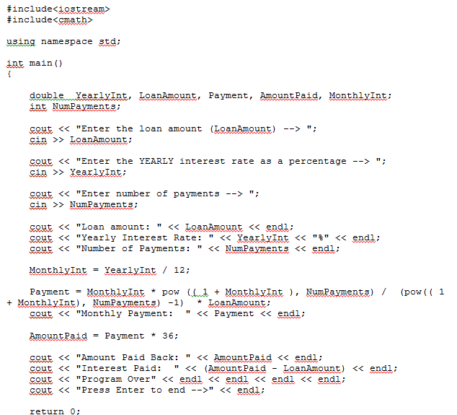

Sample C Batch Application to Calculate a Mortgage Payment

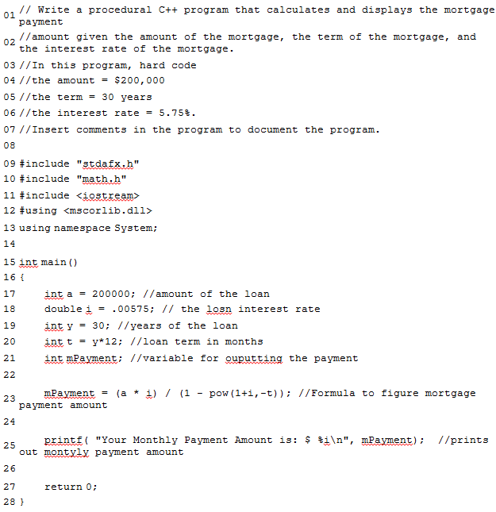

6.6 C#, VB and ASP.NET - The .NET Framework (2001, 2015)

C# is a MicroSoft's proprietary program language which borrows concepts from Java and C++. C# was introduced in 2001 that provides superior user and data interfaces than either C or C++. The C# development team is led by Anders Hejlsberg. C# 6.0 was released in 2015.

- C# is implemented on the Microsoft .NET Framework and may be combined with any .NET framework programming language designed for the Common Language Infrastructure (Visual Basic.NET and ASP.NET).
- C# is intended to be a modern, general-purpose, object-oriented programming language.
- C# is similar to C++ and Java and is not C++ and Java
- C# is classified as managed .NET code is computer program source code that requires and will execute only under the management of a Common Language Runtime virtual machine, typically the .NET Framework
- C# was designed to overcome the serious error-prone behaviors of earlier C-family languages, but C# is still not a safe as Java.
- Microsoft's Visual Studio is the most popular C# IDE. A community version of Visual Studio is now available at no cost.
- C# is limited to the Windows operating system environment. A limited open-source version of C# (Mono) is available for Linux.

6.6.1 Sample C#.NET Form and Textbox to Calculate a Mortgage Payment



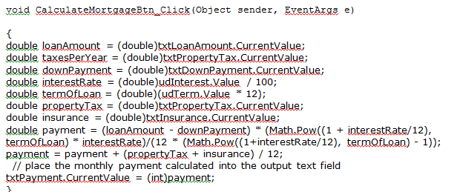

6.6.2 Visual Basic and VB.NET

VB.NET is a MicroSoft's proprietary program language which was based on Visual Basic Programming language. The original Visual Basic programming was not completely object-oriented not could be use .NET Framework classes. In 2006, the original Visual Basic program language was eliminated by Microsoft, and VB.NET was officially renamed as Visual Basic.NET. VB.NET was introduced in 2001. Visual Basic Version 14 was released in 2015.

- VB.NET is implemented on the Microsoft .NET Framework and may be combined with any .NET framework programming language designed for the Common Language Infrastructure (C#. and ASP.Net).
- Visual Basic.NET to be a simple, modern, general-purpose, object-oriented programming language.
- Visual Basic. NET is classified as managed .NET code is computer program source code that requires and will execute only under the management of a Common Language Runtime virtual machine, typically the .NET Framework
- C# was designed to overcome the serious error-prone behaviors of earlier C-family languages, but C# is still not a safe as Java.
- Microsoft's Visual Studio is the most popular Visual Basic .NET IDE. A Visual Basic Studio Community version of Visual Studio is now available at no cost.
- C# is limited to the Windows operating system environment. A limited open-source version of C# (Mono) is available for Linux.

6.6.3 Sample VB.NET Form and Textbox to Calculate a Mortgage Payment

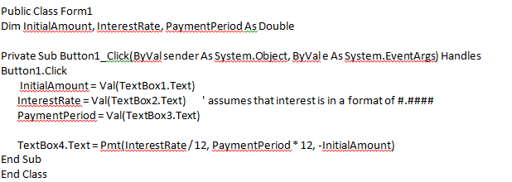

6.6.4 ASP.NET and the .NET Framework

- ASP.NET is an open-source server-side web application framework designed for web development to produce dynamic web pages. It was developed by Microsoft to allow programmers to build dynamic web sites, web applications and web services.
- Active Server Pages (.ASP), also known as Classic ASP, was introduced in 1998 as Microsoft's first server side scripting engine. ASP was interpreted and executed on the server side under MicroSoft's Internet Information Server.
- ASP.NET (.ASPX) is a new ASP generation. It is not compatible with Classic ASP, but ASP.NET may include Classic ASP syntax.ASP.NET pages are compiled, which makes them faster than Classic ASP.
- Server-based code can create dynamic web content on the fly, while a web page is written to the browser. When a web page is called, the server executes the server-based code inside the page before it returns the page to the browser. By running on the server, the code can perform complex tasks, like accessing databases.

An ASP.NET Application to Calculate Mortgage Payments
Similar to C# and Visual Basic an ASP.NET application has two parts: an xml-style ASP.NET Web form (the user interface) and a C# or Visual Private or Public Subs. This code is store in a .aspx file
Part 1: ASP.NET Web Form (Don't get scared this code was generated by the Visual Studio Drag and Drop Form Design facility
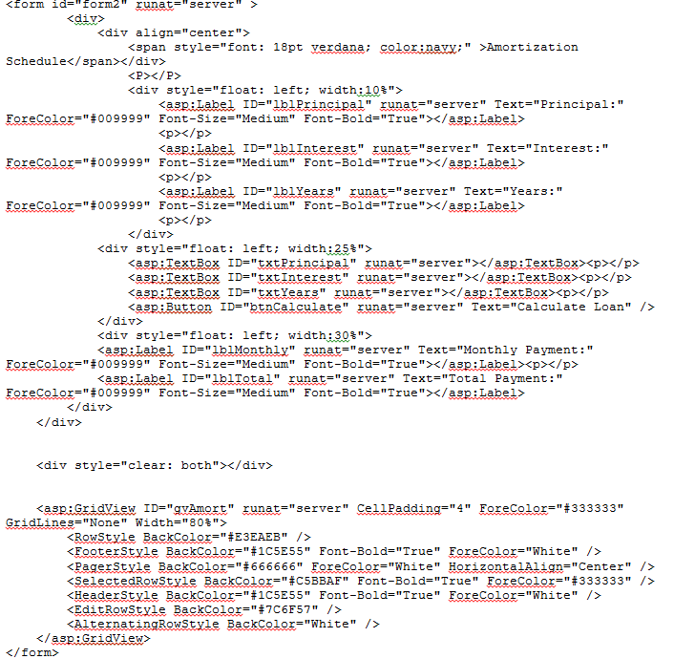

Part 2: Visual Basic. NET Code
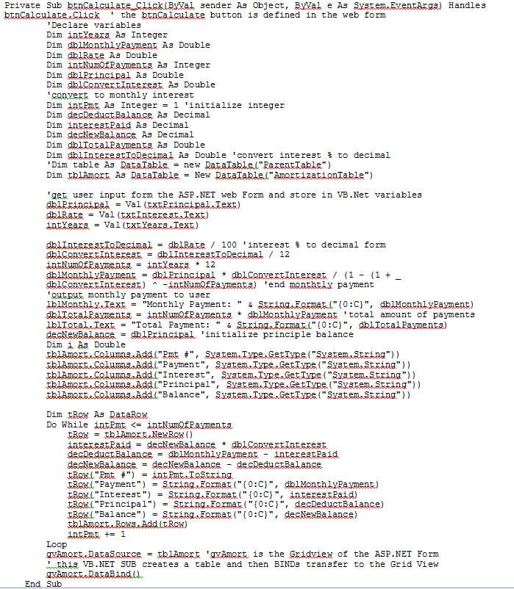

ASP.NET is a dynamic web page description language, which relies on other languages to provide greater processing capabilities.

6.6.5 ASP.NET Razor

One may mix and use standard HTML code, as well as the ASP.NET Razor server-side markup language. Razor code is embed in a basic HTML code and does not use the XML-based web page form language. The following is a simple example of ASP.NET Razor. This codes is stored is file name *.cshtml rather than *.aspx

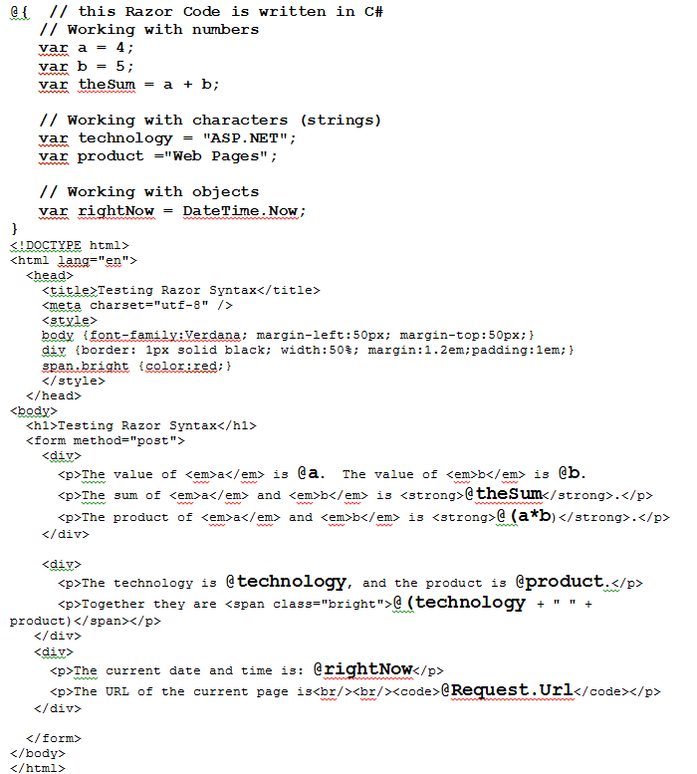

The job of any server-side language is to generate (render) dynamic HTML code and end it to the client's browser. HTML is a web page description and placement language,, not a procedural language.

Razor code is executed before the page or after the HTML document is sent to the client's browser.

6.6 Objective-C/C++ -1983, 2007

- Objective-C/C++ was originally introduced in 1983 by Brad Cox and Tom Love to improve C/C++. Objective-C/C++ version 2.x was introduced in 2007 and later became the primary application programming language for Apple's OS X and iOS operating systems and applications.
- Apple's Cocoa and Cocoa Touch framework classes (API Libraries) has added superior Apple user and data interfaces, as well as, providing classes to protect C/C++ application security vulnerabilities. The use of these enhanced security classes are not required for application development, but must be used to sell at the Apple store.
- In 2015 Swift was introduced to be more resilient to erroneous code ("safer") than Objective-C and also more concise higher level of abstraction). Several notoriously error-prone behaviors of earlier C-family languages have been changed.
- The Apple xCode IDE has been the most popular development framework.

6.7 Swift - Apple/Open Source 2015

- Swift is designed for iOS, OS X and Linux applications. Why Swift was originally a proprietary programming language introduced by Apple in 2015, Swift Release 2 (2016) is now open source and continues to be supported by Apple.
- Swift is designed to "supplement" Apples version of Objective-C and user-interface called Cocoa and Cocoa Touch Frameworks.
- Swift application code can be developed by Apples Xcode Version 6 uses the Objective-C runtime, which allows C, Objective-C, C++ and Swift code to run within a single program.[
- Swift is intended to be more resilient to erroneous code ("safer") than Objective-C and also more concise higher level of abstraction). Several notoriously error-prone behaviors of earlier C-family languages have been changed:
- Assignments do not return a value. This prevents the common mistake of writing i=0 instead of i==0 by throwing a compile-time error.
- No need to use break statements in switch blocks. Individual cases do not fall through to the next case unless the fallthrough statement is used.
- Variables and constants are always initialized and array bounds are always checked.
- Integer overflows, which result in undefined behavior for signed integers in C, are trapped as a run-time error in Swift. Programmers can choose to allow overflows by using the special arithmetical operators &+, &-, &*, &/ and &%. The properties min and max are defined in Swift for all integer types and can be used to safely check for potential overflows, as opposed to relying on constants defined for each type in external libraries.
- The single-statement form of if, which allows for the omission of braces around the statement, is not supported.

6.8 PHP

- PHP (recursive acronym for PHP: Hypertext Preprocessor) is a widely-used open source general-purpose scripting language that is especially suited for web development and can be embedded into HTML.
- Instead of lots of commands to output HTML (as seen in C or Perl), PHP pages contain HTML with embedded code that does "something" (in this case, output "Hi, I'm a PHP script!").
- The PHP code is enclosed in special start and end processing instructions <?php and ?> that allow you to jump into and out of "PHP mode."

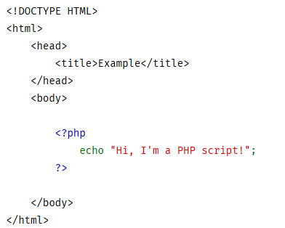

- What distinguishes PHP from something like client-side JavaScript is that the code is executed on the server, generating HTML which is then sent to the client.
- The client would receive the results of running that script, but would not know what the underlying code was. You can even configure your web server to process all your HTML files with PHP, and then there's really no way that users can tell what you have up your sleeve.

- There are three main areas where PHP scripts are used.

Server-side scripting. This is the most traditional and main target field for PHP. PHP can be used to create dynamic web sites

Command line scripting. You can make a PHP script to run it without any server or browser. You only need the PHP parser to use it this way. This type of usage is ideal for scripts regularly executed using cron (on *nix or Linux) or Task Scheduler (on Windows).

Writing desktop applications. PHP is probably not the very best language to create a desktop application with a graphical user interface.

- PHP can be used on all major operating systems. PHP has also support for most of the web servers today. With PHP you are not limited to output HTML.

- PHP is normally distributed as an open-source (free) dynamic web architecture, which includes web server, e.g., Apache, the PHP parser or interpreter, and the MySQL database bundled for Linux (LAMP), Windows (WAMP), and Mac OSX (MAMP).

6.9. Python

6.9.1 Introduction
Python is a general purpose programming language created in the late 1980s, and named after Monty Python, which historically started by focusing on easy-to-develop, dynamic web sites. While both PHP and Python are interpreted languages, PHP was never designed to be a general purpose programming language like C, Java, .NET, etc.
Python is easy to learn, very closely resemble the English language, and has very large number of frameworks. These frameworks support a wide variety of applications, such as, social media interfaces, server automation, debugging tools scientific calculations, and image manipulation, beyond supporting dynamic web sites.
Unlike PHP which is embedded in a web server, Python provides for a separate process which is the execution model used by Java and .NET.
The bottom line Python provides the power and flexibility of Java, C, C++, or C#, yet is easier to learn and code.

6.9.2 Data Analytics: R versus Python
Data Analytics. R is a popular open-source (free) programming language which includes a more powerful statistical library than Python. Statistical libraries are very important for Big Data Analytics (Systems of Insights) designed for standalone applications and batch processing. However, Python is increasingly being used for real time data analytic tasks which needs to be incorporate web apps or requirement to use a production database. In addition, Python was better security libraries and uses better memory management.

6.9.3 Python Sample Code
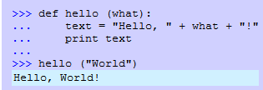

6.10 Scala

6.10.1 Introduction to Scala and Functional Programming

- Scala is an object-oriented, general purpose programming language, was created by Martin Odersky, providing support for functional programming.

- An important objective of any objective-oriented programming language to improve the reusability of program code and provides for wide functionality (does more). On the other hand, the primary function program languages is tow "Write less, do more." With Scala, a programmer is more like an architect, rather than a construction worker. For example, you can write a slightly more complex single line of code that replaces 20 “simpler” lines of Java. Which one is really more complex – more code or more complex functions?

6.10.2 Scala was designed to overcome Java's shortcomings.

- Designed to be concise, many of Scala's design decisions were inspired by criticism of Java's shortcomings. Java is a very verbose language, was not designed for performance-critical workloads, does not scale well (multicore and multi processed system. Scala was created specifically with the goal of being a better language, shedding those aspects of Java which it considered restrictive, overly tedious, or frustrating for the developer.

- Scala source code is intended to be compiled to Java bytecode, so that the resulting executable code runs on a Java virtual machine. Scala provides language interoperability with Java, so that libraries written in both languages may be referenced directly in Scala or Java code.

- Python is a very simple to learn and highly productive language to get things done quickly and from day 1. Scala requires a little bit more of thinking and abstraction due to its high level functional features but as soon as you get familiar with that, your productivity will dramatically boost.

6.10.3 Big Data Analytics: Hadoop and Spark

- Many of the high performance data science frameworks that are built on top of Hadoop usually are written and use Scala or Java. The reason Scala is used in these environments is because of its amazing concurrency support, which is key in parallelizing a lot of the processing needed for large data sets. It also runs on the JVM, which makes it almost a no-brainer when paired with Hadoop.

- While many would expect that Scala may be more appropriate for real-time data analytics using Spark, there is little difference between Scala and Python with in-memory analytics. There is a general agreement that if the data can fit in memory (Spark), Python would be a better programming language since it provide dynamic web application services. If the data cannot not fit into memory (Hadoop), then Scala would be the better programming language, but any web application service can provide by almost any programming language, e.g., Java, C#, PHP, Swift, Objective-C, R, etc.

6.11 R Programming

R is both an open source programming language and a software environment for statistical computing and graphics. R was designed for user-friendly data analysis statistics and graphical models, rather than flexible, general purpose programming language.

R has been primarily used in academic and research, whereas, engineers and programmers would prefer to use Python or to integrate some other program language. Most programming languages, e.g., Java, C#, Python, Scala, Objective-C, etc. can easily be integrated with R statistical and graphic functions. This also includes COBOL and Excel.

R's statistical and graphic modeling features can be compared to SAS (privately-owned) and SPSS (IBM-owned). SAS is a leader in business analytics software and services, and the largest independent vendor in the business intelligence market. Both SAS and SPSS are expensive data handling and data analytic solutions. SPSS is easier to use and supports a wide variety of drop-down menus. However, products like Tableau, which is built on R, is also very user friendly.

6.12 Rexx

6.12.1 Introduction
- Rexx is a procedural programming language developed by IBM that allows programs and algorithms to be written in a clear and structured way. While Rexx continues to be used on a mainframe for system administration, there are over nine open-source versions which can be used on every server, desktop or mobile operating system.
- It is easy to use by experts and casual users alike. Rexx has been designed to make easy the manipulation of the kinds of symbolic objects that people normally deal with such as words and numbers.

6.12.1 Advantages of Rexx
- Although Rexx has the capability to issue commands to its host operating system or to call programs and functions written in other languages, Rexx is also designed to be independent of its supporting system software when such commands are kept to a minimum.
- Rexx is a major glue language that ties together all important mainframe processing.
- Rexx has evolved into a major object-oriented language and can be executed in a Java Virtual Machine.
- Unlike most other programming language, Rexx is backward compatible.

6.12.3 Rexx Program Example
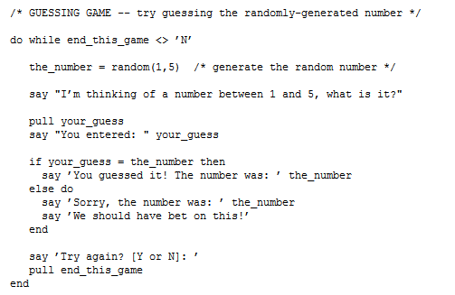

7.0 Frameworks - What is a Java or .NET API Framework?

A Java API (Application Program Interface) Framework is a collection prewritten packages, "compiled" classes, and interfaces with their respective methods, fields and constructors. Similar to a user interface, which facilitates interaction between humans and computers, an API serves as a software program interface facilitating the interaction prewritten framework code with customized code written by a programmer to implement program requirements.

The concept of the level of abstraction was previously introduced. Programming languages with a high level of abstraction attempts to re-use prewritten program code, requires fewer lines of additional code to use the prewritten code, and hides the details of re-using prewritten code. The objective is high levels of abstraction is to code new program requirements faster with fewer program development errors.

Consider the analogy of purchasing a new home. A building contractor lays the building foundation, "frames" the wood structure of house, installs utilities, interior walls and remaining major structural or "framework components. At this point of the new house construction, my wife takes over the completion stage of the house. (My wife has watch every episode of HGTV and desires to have her own show on HGTV.)

At this point, my wife or any home buyer, will work with the building contractor to customize and complete (implement) the finished house. These tasks may include choosing the electric and plumbing fixtures, carpet, paint, kitchen cabinets and appliances, and then we moved into a customized new home.

In the previous definition of an API, two concepts were bolded: framework and implementation. The concept of program language frameworks was derived from the concept framing the framing wood structure of a new building. A Framing Carpenters creates the overall structure of a home. A Finishing or Cabinet Carpenter adds the finishing touches to the framework. There may be tens of homes in your building plan that has the same framework structure, but each was customized for the individual owner. In the context program language frameworks, one uses the terminology of the implementation of the framework. The concept of implementation simply means to customize to meet the needs of the program requirements.

The Java Standard Edition (Platform) contains a framework called Swing. The role of the Swing framework is to a collection prewritten packages, classes, and interfaces with their respective methods, fields and constructors TO DEVELOP A GRAPHICAL USER INTERFACE, similar to a .NET Form. So you want to code a command button to multiply the values stored in two text boxes. To implement (code or customize) the command button will require a physical storage area and appearance and commands to react to a click on the command button and process the program requirements, i.e., to multiply.

So does anyone know how to code the details of simply displaying a command button? I don't. But, I can use the Swing framework that will provide me a generic command button object to code or customize (to implement) the command button that meets my design that meets my command button position and appearance requirements. Using the Swing framework command button the programmer specifies position, size, fonts, borders and color, similar to way my wife provided the building contractor her design requirements.

During the 1980s, Basic programming teachers would teach their students to code a program which required an object similar to command button, respond to a mouse-click and then would execute a series of Basic statements in response to a mouse click. This program was introduced in the 12th week of a 15-week semester. Now we can introduce these concepts very early in semester.

More Details …

7.1 Java Platform/Edition, Java Framework, and Java Package

While these concepts are often used interchangeably, there are differences.

- A Platform/Edition will contain a collection of framework packages to implement a major category of application development. For example, Java SE contains both Java Swing and Java Security Frameworks. Loosely applying the building contractor analogy, a Platform is the building contractor's construction plan (site) which contains different types of homes, each with a different structure, e.g., one-story, two-story, patio, and carriage homes.

A Framework is "conceptually" a collection or prewritten packages, classes or so forth. The package is "physical" structure (folders) which actually stores the collection or prewritten packages, classes or so forth.

7.2 Java Library, Java Package, Name Spaces, Java Framework, and Java API

While these concepts are often used interchangeably, there are differences.

A Program Library is physical file system concept used to organize compiled code. The concept of a program library was introduced by IBM mainframes over five decades ago. To organize files or data sets IBM used a storage structure called a partitioned data set (PDS). Programmers would use two different partitioned data sets. One PDS was created to store the program source code and a second PDS was created to store compiled code, or executable load modules. The terminology "Library" was used to distinguish the PDS that stored compile code versus source code.

Later the UNIX, Linux and Windows files systems became popular. We now use terminology subdirectories and folders to organize our files. While a PDS is not used in these modern files systems, many programmers used the terminology a "library" to describe a folder or subdirectory that contained executable (compiled) load modules.

And finally, objective programming languages became popular and Java Packages or .NET namespaces were used to organize executable (compiled) program code, rather than source code. Sound familiar? Therefore, the concept of a program library, package or namespace represent a storage method used to store and organize executable code, but will differ by operating system and type of programming language.

IBM z System me Procedural Application

A Java or .NET Frameworks is a collection of program libraries, packages or namespaces to organize a collection of prewritten compiled programs. IBM mainframe operating systems, e.g., z/OS, do not use the concept of frameworks, but rather use the terminology of a subsystem.

 | IBM Mainframe Procedural Applications | Windows, UNIX and Linux Procedural Applications | Object-Oriented Programming Languages
Collection of Compiled Programs to Support Specific Requirements | Subsystems  A subsystem contains one or more PDSs | Frameworks  A framework contains one or more directories | Frameworks  A framework contains one or more directories
Operating system storage structure to organize compiled programs | Partitioned Data Set (PDS) | Subdirectories and Folders | Subdirectories and Folders
Terminology used to describe storage structure of compiled code | Library  A library contains more than one compiled programs | Library  A library contains more than one compiled programs | Java - Package  .NET - Name Space  A package or name space contains more than one classes
Compiled programs | load module or  PDS member | executable file | class

Many will use the concepts of API and Frameworks (classes) interchangeably. This over simplification may not be acceptable. An Application Program "Interface" is a communication structure that specifies the rules for your customized classes to communicate and use the Framework classes. APIs are a part of a Framework. APIs are optional, but framework classes are not.

When you confused about programming terminology, always return to the analogy of the building contractor (the framework classes) and my wife's decorating and finishing ideas (the customized classes). After watching an episode of HGTV, my wife calls the contractor and requests that the bed room be painted in "Dorian Grey and the trim should be white and the trim should "pop-out". After finishing his Iron City beer the contractor calls me, "What is your wife talking about?" So I became the "building contractor and wife interface."

First, the building contractor didn't understand my wife's specifications for the color Dorian Grey. Second, the contractor did not know the name of paint manufacturer, stock number, type of paint finish and other painting requirements. And third, the building contractor did not also understand "what the color white was" or "what specific trim was to be painted." The bottom line the contractor required additional details that be used to purchase the paint and then specify procedural requirements for his painters.

Relationship between User Application Classes, the API and Framework Classes
Customized Packages | Framework Packages
Customized Classes  (wife's requirements) | Application Program Interface  (optional)  rules to access and use the frameworks classes  Make sure that my wife and contractor are both happy | Framework Classes  (contractor requirements)

While my wife required the services of the contractor, it was my duty that to make sure that the contractor understood her requests while providing information that the contractor needed to do their work.

While APIs may be are optional, two additional benefits should be considered.

- First, the procedural details of framework classes are hidden. My wife does not care how the contractor does work. She just requires her design specifications be executed.
- Second, if the contractor may change their paint supplier, or may change procedural requirements, my wife does not care. Therefore, the application program does not have change if the framework classes change. Security framework classes will frequently change, but previous security APIs may be retained.

